### A REAL TIME PROJECT REPORT ON

EV CHARGING PATH

**A PROJECT SUBMITTED IN PARTIAL FULFILLMENT OF THE REQUIREMENT FOR THE AWARD OF THE DEGREE OF**

## BACHELOR OF TECHNOLOGY

**IN**

## Electronics & Communication Engineering SUBMITTEDBY

**M.SAI CHARAN 237R5A0402**

## S.VIKAS 237R5A0401

**K.NITHIL 227R1A0433**

## M.PAVAN 227R1A0439

**UNDER THE GUIDANCE OF**

## DR. G. SRIKANTH

### Professor, & HOD, ECE DEPT



**DEPARTMENT OF ELECTRONICS AND COMMUNICATION ENGINEERING**

### CMR TECHNICAL CAMPUS UGC AUTONOMOUS

**Kandlakoya (V), Medchal Road, Hyderabad-501401 (2020-2021)**

**DEPARTMENT OF ELECTRONICS AND COMMUNICATION ENGINEERING**

# CMR TECHNICAL CAMPUS

**UGC AUTONOMOUS**

# Kandlakoya (V), Medchal Road, Hyderabad-501401



**CERTIFICATE**

This is to certify that the dissertation work entitled **“EV CHARGING PATH”** being submitted by **M.Sai charan, S.vikas, K.Nithil and M.pavan** bearing **Roll Numbers 237R5A0402, 237R5A0401, 227R1A0433 and 227R1A0439** respectively, in partial fulfillment for the degree of **Bachelor of Technology** in **“ELECTRONICS AND COMMUNICATION ENGINEERING”** during the academic year 2023–2024.

Certified further, to the best of our knowledge that the work reported is not a part of any other project on the basis of which a degree or an award has been given on an earlier occasion to any other candidate. The results have been verified and found to be satisfactory.

**Internal Guide Head of the Department**

### Dr. G. SRIKANTH Dr. G. SRIKANTH

**Professor Professor & HOD, ECE Dept.**

**Director**

**Dr. A. RAJIREDDY**

# ACKNOWLEDGEMENT

We thank **Dr.Ch.Sudhamani** Associate Professor, Department of ECE for her constant guidance over the past six months, and for providing required guidance as internal guide for result oriented implementation of ideas relevant to my project.

We thank **Dr. G. Srikanth,** Real Time Project Coordinator for his constant support in carrying out the project activities and reviews.

We thank **Dr. G. Srikanth**, HOD of Electronics and Communication Engineering for providing seamless support and knowledge over the past one year and for providing right suggestions at every phase for successful completion of my project.

We express my whole-hearted gratitude to **Dr. A. Raji Reddy**, Director, **CMR Technical campus** for providing us the conducive environment for carrying out my academic schedules and projects with ease.

There is a need to thank all staff members, friends and parents without whose support project would have been deferred.

### M.SAICHARAN (237R5A0402)

**S.VIKAS (237R5A0401)**

### K.NITHIL (227R1A0433)

**M.PAVAN (227R1A0439)**

# ABSTRACT

The increasing demand for sustainable transportation solutions due to the depletion of traditional energy resources has led to the development of innovative technologies for electric vehicles (EVs). However, the widespread adoption of EVs hinges on addressing critical challenges in charging infrastructure, particularly the need for convenient, efficient, and on-the-go charging mechanisms. In response, this project presents a groundbreaking approach to EV charging through Dynamic Wireless Charging (DWC) technology, leveraging Magnetic Resonance Coupling (MRC) principles.

The prototype system developed operates at certain frequency, offering a robust solution for Plug- in Electric Vehicles (PEVs) burdened by conventional cable and plug chargers. By eliminating the physical tethering of chargers, DWC not only enhances user convenience but also achieves inherent electrical isolation, reduces onboard energy storage system (ESS) sizes, and streamlines regulatory compliance. These advancements not only optimize the charging process but also pave the way for sustainable, eco-friendly transportation ecosystems.

The core innovation lies in the resonant magnetic coupled wireless power transfer technology, which establishes a seamless energy transfer interface between the charging infrastructure and EVs. Through a loosely coupled system with carefully tuned resonant capacitors, the project ensures efficient power transfer while minimizing losses and maximizing safety.

The proposed system envisions a future where electric vehicles seamlessly integrate with smart road infrastructure, receiving continuous power boosts while in motion. By intelligently harnessing wireless charging opportunities, this project underscores the transformative potential of DWC- MRC(Dynamic Wireless Charging - Magnetic Resonance Coupling )technology in revolutionizing urban mobility and advancing towards a greener, more sustainable transportation paradigm.

# CONTENTS

### LIST OF CONTENTS PAGE NO

**ACKNOWLEDGEMENT I**

ABSTRACT II

LIST OF FIGURES III

CHAPTER 1: INTRODUCTION

1. INTRODUCTION  1

CHAPTER 2: LITERATURE SERVEY 4

CHAPTER 3: EV CHARGING PATH

* 1. INTRODUCTION TO PROJECT 9
  2. BLOCK DIAGRAM 11
     1. DC Power Source 11
     2. . Oscillator 11
     3. Transmitter Coil 11
     4. Receiver coil 12
     5. Rectifier 12
     6. Voltage Regulator IC 12
     7. Low Power Device 12
  3. HARDWARE DESCRIPTION 13
  4. CIRCUIT DESCRIPTION 25

3.4.1 Transmitter circuit 26

3.4.2 Receiver circuit 27

3.4.3 Circuit Operation 27

3.4.4 key points 28

CHAPTER 4: RESULTS AND ANALYSIS

4.1 Result 29

CHAPTER 5: CONCLUSIONS AND FUTURE SCOPE

* 1. Conclusion 31
  2. Future Scope 31

**CHAPTER 6: BIBILOGRAPHY** 32

# LIST OF FIGURES

Fig.3.1 Block Diagram 11

Fig.3.2 coil 13

Fig.3.3 Transistor 15

Fig.3.4 LED 16

Fig.3.5 capacitors 18

Fig.3.6 Resistor 19

Fig.3.7.Battery 20

Fig.3.8.Connector 21

Fig.3.9.Heat Sink 22

Fig.3.10.Diode 24

Fig.3.11 circuit diagram 25

Fig.3.12 Charging lane 28 Fig:4.1 vehicle discharging 29

Fig.4.2 Vehicle is charging 30

# CHAPTER 1

**INTRODUCTION**

## 1.Introduction to EV

### Overview

The transportation sector has undergone significant transformations over the past century, transitioning from traditional internal combustion engine vehicles (ICEVs) powered by petrol and diesel to modern electric vehicles (EVs). This evolution is driven by the need to address environmental concerns, reduce dependency on fossil fuels, and embrace sustainable energy sources. Electric vehicles, with their promise of zero emissions and reduced operational costs, are at the forefront of this automotive revolution.

**Evolution of Vehicles: From Petrol and Diesel to Electric Early Automotive Era**: Petrol and Diesel Dominance

The early 20th century marked the rise of petrol and diesel-powered vehicles, which quickly became the standard due to their relatively high energy density, ease of refueling, and established oil infrastructure. The internal combustion engine (ICE) technology enabled vehicles to achieve greater ranges and power outputs, fueling the growth of personal and commercial transportation. Over the decades, advancements in engine technology, fuel efficiency, and vehicle design continuously improved the performance and reliability of petrol and diesel vehicles.

### Environmental Concerns and the Quest for Alternatives

As the global automotive fleet expanded, so did concerns about the environmental impact of fossil fuels. The burning of petrol and diesel releases significant amounts of greenhouse gases (GHGs) such as carbon dioxide (CO₂), contributing to climate change and air pollution. These concerns prompted researchers and policymakers to seek cleaner and more sustainable alternatives. The oil crises of the 1970s further underscored the need for energy diversification and spurred interest in alternative fuel sources.

### Emergence of Electric Vehicles

Electric vehicles are not a new concept; early experiments with electric propulsion date back to the late 19th and early 20th centuries. However, the limitations of battery technology and the dominance of ICEs relegated EVs to niche applications. It wasn’t until the late 20th and early 21st centuries that technological advancements in battery chemistry, particularly the development of lithium-ion batteries, reignited interest in EVs. These advancements enabled higher energy densities, longer ranges, and shorter charging times, making EVs a viable alternative to petrol and diesel vehicles.

### Modern Electric Vehicle Revolution

The modern era of EVs began in earnest with the launch of commercially viable electric cars such as the Tesla Roadster in 2008, which demonstrated the potential for high-performance electric mobility. This was followed by the introduction of mass-market EVs like the Nissan Leaf and the Chevrolet Volt, which further popularized electric propulsion. Governments worldwide began to implement policies and incentives to promote EV adoption, including tax credits, subsidies, and investments in charging infrastructure.

### The Role of Wireless Power Transfer in EV Evolution

Despite their advantages, EVs face challenges related to charging convenience and infrastructure. Traditional plug-in charging methods can be cumbersome and time-consuming. Wireless power transfer (WPT) technology offers a promising solution by enabling efficient, contactless charging. WPT systems can enhance the practicality of EVs by allowing for dynamic on-road charging, reducing the need for large energy storage systems (ESS) on board, and eliminating the need for physical connectors.

### Project Scope and Objectives

The primary objective of this project is to design and develop a wireless power transfer system for electric vehicles using resonant magnetic coupling technology. Operating at a frequency of 60 kHz, the system aims to provide a practical and reliable solution for EV charging. The project involves creating a prototype WPT system, optimizing the design of primary and secondary coils, and testing the system’s performance under real-world conditions.

### Importance of the Project

This project is significant for several reasons:

Environmental Impact: Promoting the adoption of EVs through improved charging technologies can significantly reduce greenhouse gas emissions.

Convenience and Safety: Wireless charging offers a safer and more convenient alternative to plug- in systems, enhancing user experience.

Infrastructure Development: Developing efficient WPT systems supports the broader adoption of EVs by addressing key infrastructure challenges.

# CHAPTER – 2

**LITERATURE SURVEY**

## ELECTRIC VEHICLE CHARGING INFRASTRUCTURE ALONG HIGHWAYS IN THE EU

**Published in**: **MDPI** (**multidisciplinary digital publishing institute) Authors**: Emilia M. Szumska

**ISSN:** 2395-0056,Volume: 9,pp.2395-0072

**Abstract:** One aspect of the competitiveness of electric and plug-ins hybrid vehicles is the ability to recharge batteries quickly. Ideally, this process would take no longer than it takes to refuel vehicles powered by conventional fuels. The term fast charging is generally used to refer to alternating current (AC) charging of more than 22 kW and direct current (DC) charging often referred to as fast or ultra-fast charging at high power. Currently, fast charging points are located within the public charging infrastructure, mainly along highways. The purpose of this paper was to analyze the availability of existing charging infrastructure equipped with fast charging points for electric vehicles in European Union countries. In addition, the paper discusses EU policy in terms of zero-emission vehicles and technical issues related to charging infrastructure. Based on a review of the current state of charging infrastructure and plans for its development in light of the EU Green Deal for Europe regulations, it can be concluded that in many regions the fast charging infrastructure for electric cars is still insufficiently developed. Due to the great economic diversity of EU countries, the development of charging infrastructure proceeds at different paces. For this reason, it is important to ensure that fast charging points are located primarily along the TEN-T network and highways.

### Keywords:

[**electric vehicle**](https://www.mdpi.com/search?q=electric%2Bvehicle); [**plug-in hybrid**](https://www.mdpi.com/search?q=plug-in%2Bhybrid); [**electric vehicle charging infrastructure**](https://www.mdpi.com/search?q=electric%2Bvehicle%2Bcharging%2Binfrastructure); [**fast charging**](https://www.mdpi.com/search?q=fast%2Bcharging)

## THERMO-VISCOELASTIC ANALYSIS OF AN INDUCTIVE CHARGING SYSTEM INCLUDED IN AN EROADS. INCIT-EV PROJECT

**Published in**: Transportation Engineering – science direct

**Authors:** Thomas Gabet

**ISSN:**Volume 11, March 2023, 100161

**Abstract:** This paper presents work carried out in WP4 of the European project INCIT- EV, to develop a thermo-mechanical model, for simulating the performance of electrified roads using an inductive system for the charging of electric vehicles. The system consists of a charging unit, made of a box containing a litz coil, inserted into the road, at low depth under the surface, and sealed using a resin. In previous studies [[1]](https://www.sciencedirect.com/science/article/pii/S2666691X23000027#bib0001), several solutions for the insertion of this system in the road structure were evaluated, using experimental and numerical studies. The purpose of this paper is to highlight the potential of thermo-viscoelastic FEM structural simulations to predict the response of the electric road system (ERS) taking into account daily thermal variations, and heat released by the inductive charging system. Firstly, thermal laboratory tests were performed to evaluate the temperature variations due to the operation of the charging system, and compared with FEM simulations, in order to validate different modelling assumptions (material characteristics, boundary conditions). Then, transient thermo- mechanical simulations were performed, considering different materials for the coil block (polyethylene, or concrete), and for the sealing resin, in order to evaluate different possible designs of the charging elements. The variations of the deformations of the different structures, and of the strain and stress fields, during representative temperature cycles, were studied and compared. Differences in mechanical response obtained with different sealing resins (elastic or viscoelastic) and different coil block materials (polyethylene, and concrete) were analysed and compared.

## 3.A COMPREHENSIVE REVIEW OF THE RECENT DEVELOPMENT OF WIRELESS POWER TRANSFER TECHNOLOGIES FOR ELECTRIC VEHICLE CHARGING SYSTEMS

**Published in:** Institute of Electrical and Electronics Engineers(IEEE)

**Authors:** [Amritansh Sagar](https://ieeexplore.ieee.org/author/37088479316) [Arun Kashyap](https://ieeexplore.ieee.org/author/37089978711); [Morteza Azimi Nasab](https://ieeexplore.ieee.org/author/37088374163); [Sanjeevikumar](https://ieeexplore.ieee.org/author/37089659833) [Padmanaban](https://ieeexplore.ieee.org/author/37089659833); [Manuele Bertoluzzo](https://ieeexplore.ieee.org/author/37281933600)

**ISSN:** 2169-3536, Volume-11, Issue- 01 August 2023

**Abstract:** The expanding Electric vehicle (EV) market is fueled by the need for more efficient and dependable ways to recharge the battery. By eradicating the necessity for direct physical interaction between vehicles and charge equipment, the Wireless Power Transfer (WPT) methodology eliminates the drawbacks and risks associated with the conventional conductive system. The innovative WPT technique replaces the conductive charging system to keep a similar power rating and efficiency. Numerous strategies have been created to improve the effectiveness and dependability of the WPT model. As a result, this review article thoroughly analyses current major research literatures that describe WPT technologies for EV charging. The papers are classified based on various coupling types along with magnetic couplers and shielding, compensation, misalignment tolerance and control methods in WPT systems. In addition, the possible research gaps and the challenges associated with the existing works of WPT systems are discussed. The reviewed results are analyzed based on performance metrics and implementation tools attained using above classifications and EMF exposure references employed in the WPT system. The comparative effectiveness is presented in the tables, diagrams, as well as interconnections for ease of presentation and conceptual understanding. The core asset of this article lies in the fact that the findings offer a good “one-stop” resource including both aspects of the system and with regard to the power stage. This review article also emphasizes the potential and obstacles of inductive wireless EV battery chargers. A developer can find this study will contribute substantially to selecting an optimum design for the enhancement of the WPT system.

## DESIGN OF A PAVEMENT SOLUTION FOR ELECTRIC VEHICLE CHARGING BY INDUCTION

**Published in:** HAL open science

**Authors:** Pierre Hornych , Thomas Gabet , Brahim Mazhoud , Eric Coquelle , Zariff

### ISSN: -

**Abstract:** In recent years, with the rapid development of electric vehicles (EVs), the design and evaluation of different solutions for recharging these vehicles have been the subject of numerous studies. In particular, dynamic inductive charging appears as a promising charging solution, offering several advantages: no physical connection with the vehicle, no manipulation by the user during charging, and reduced risk of damage or vandalism of the system, which is integrated into the road. This paper presents the work carried out in the framework of the European project INCIT-EV (2020-2024), aiming at developing a dynamic charging system by induction for electric vehicles (cars and light utility vehicles), intended for urban applications, with a charging power of 30 kW. An important issue in the development of inductive charging systems is the integration into the pavement structure, to ensure the electrical efficiency, durability and traffic resistance of the inductive coils, integrated into the pavement. This article presents the studies carried out in the INCIT-EV project to design an Electric Road demonstrator, integrating an inductive charging system, to be built in Paris. Within the framework of the project, specific tests have been developed to study the mechanical and thermal behavior of this electric road. In particular, laboratory rutting tests have carried out to study, on a reduced scale, the mechanical behavior of a recharging coil integrated into the pavement. Charging tests were also carried out to study the charging efficiency and the temperature variations produced by the heat dissipation in the charging system. These laboratory studies were complemented by finite element calculations to simulate the thermal and mechanical response of the system in the pavement structure. The studies have allowed to select appropriate materials for the integration of the inductive coils, and to propose a suitable road design for the demonstrator, which will be built in Paris in 2023.

## DESIGNING INDUCTIVE COILS FOR WIRELESS POWER TRANSFER FOR ELECTRIC VEHICLES

### Published in: AIP conference Proceedings

**Authors**: A. Sai Praneeth C. Harshavardhan, K. Triloknath ,S. Lekshmi

**ISSN:** - **,** DECEMBER 15 2023 [Volume 2901, Issue 1](https://pubs.aip.org/aip/acp/issue/2901/1)

**Abstract:** In present day with increase in pollution, fuel prices and depletion in resources, world is moving towards renewable energy. In this process Electric Vehicles (EV) play a major role. In the automobile industry EVs are the future because every country, industry is trying to decrease global warming and pollution by using technology which is sustainable. Electrical vehicle uses power from batteries to run. Batteries need to be charged to use electric vehicles. The charging system of EV can be either wired or wireless. Considering various advantages and disadvantages, Wireless Power Transfer (WPT) system is found to be one of the most efficient technique. In this work the design of wireless power transfer for electric vehicle to grid technology and the compensation network for the same is discussed. The inductive coils, transmitter and receiver are designed and simulated in ANSYS Maxwell platform. Different model of coils with and without magnetic shielding are compared. Quality factor of transmitter and receiver of every model is calculated and results are tabulated. The coil model with good power transfer efficiency is discussed. Choosing the best performed coil, efficiency comparison with varying distance between the coils is studied and results are tabulate

# CHAPTER – 3

**EV CHARGING PATH**

### INTRODUCTION TO PROJECT:

As global energy resources continue to deplete, there is an urgent need to develop alternative and sustainable transportation solutions. Electric vehicles (EVs) have become increasingly popular as they offer a cleaner, more environmentally friendly option compared to traditional fossil fuel- powered vehicles. Despite their benefits, the adoption of EVs faces significant challenges, primarily related to battery capacity, lengthy charging times, and the convenience of charging infrastructure.

Traditional plug-in charging methods require vehicles to be stationary for extended periods, during which they must be connected to a charging station using cables and connectors. This not only limits the mobility of EVs but also poses practical difficulties for users who may not have easy access to charging stations.

To overcome these limitations, this project investigates the use of dynamic wireless charging for electric vehicles, utilizing resonant magnetic coupling technology. The objective is to design and implement a prototype wireless charging system that operates at a 60 kHz frequency, capable of charging EVs while they are in motion. This approach eliminates the need for physical connectors and allows for continuous charging, thereby reducing the size of onboard energy storage systems and enhancing the overall convenience for users.

The core of the wireless power transfer (WPT) system involves primary and secondary coils that form a loosely coupled resonant system. By tuning the receiver coil on the vehicle to the same resonant frequency as the transmitter coil embedded in the roadway, efficient power transfer can be achieved. This project will cover the design and development of both the transmitter and receiver circuits, the selection of components, and the practical implementation of the system.

In addition to improving the convenience and efficiency of EV charging, this project aims to contribute to the broader adoption of wireless technology in various applications. As the world moves towards a more wireless future, innovations in WPT have the potential to revolutionize not only the automotive industry but also a wide range of consumer electronics and industrial applications.

This document provides a comprehensive overview of the project's objectives, methodology, design considerations, and practical implementation. It serves as a guide for understanding the principles of dynamic wireless charging and the steps involved in developing a functional prototype system for moving electric vehicles.

### BLOCK DIAGRAM

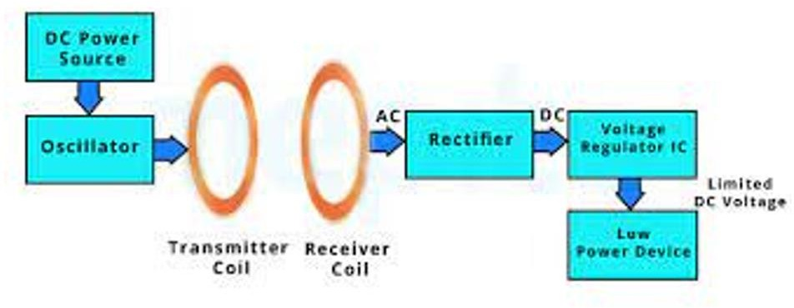

**Fig.3.1 Block Diagram**

The block diagram illustrates the key components and operational flow of the dynamic wireless charging system for electric vehicles using magnetic resonance technology.

### DC Power Source:

The system begins with a DC power source that supplies the necessary electrical power to the entire setup.

### Oscillator:

The DC power is fed into an oscillator circuit. The oscillator generates high- frequency alternating current (AC) signals. This high-frequency AC is essential for efficient wireless power transfer.

### Transmitter Coil:

The high-frequency AC signal from the oscillator is then sent to the transmitter coil. The transmitter coil converts the electrical energy into a magnetic field. This coil is typically embedded in the roadway infrastructure.

### Receiver Coil:

As the electric vehicle moves over the transmitter coil, its receiver coil, which is installed on the underside of the vehicle, captures the magnetic field. The receiver coil then converts this magnetic field back into an electrical AC signal.

### Rectifier:

The AC signal captured by the receiver coil is then passed through a rectifier. The rectifier converts the AC signal into a direct current (DC) signal. This conversion is crucial as the vehicle's electrical systems and battery require DC for operation.

### Voltage Regulator IC:

The DC output from the rectifier is then regulated using a voltage regulator IC. This IC ensures that the output voltage is stable and within the required range for safe and efficient charging of the vehicle's battery or for powering low-power devices within the vehicle.

### Low Power Device:

Finally, the regulated DC voltage is supplied to the vehicle's battery or directly to low-power devices within the vehicle, providing the necessary energy for operation or storage.

* This block diagram represents the flow of energy from the power source to the vehicle's batery, highlighting the conversion from electrical energy to magnetic energy and back to electrical energy, ensuring efficient and effective wireless charging while the vehicle is in motion.

**3.3 HARDWARE DESCRIPITION**

|  |  |  |  |
| --- | --- | --- | --- |
| S.NO | Component | value | Qty |
| 1 | Coil (Coil copper wire with 6CM dia / 5 turns) | - | 3 |
| 2 | NPN Power Transistor | BD139 | 1 |
| 3 | LED | - | 1 |
| 4 | Ceramic capacitor | 0.47uF, 10nF, 4.7nF | 1,2,2 |
| 5 | Resistor | 15k | 2 |
| 6 | Battery | 9V | 1 |
| 7 | 2-pin connector | - | 1 |
| 8 | Heat sink | - | 1 |
| 9 | Rectifier | - | 1 |
| 10 | Diode | 1N4148 | 1 |

1. 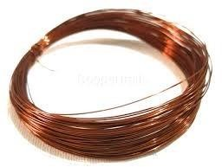**Coil (Coil copper wire with 6CM dia / 5 turns)**

### Fig.3.2 coil

Description:

A coil, also known as an inductor, is a passive electrical component consisting of wire wound into a spiral or helix. The coil in question is made of copper wire with a diameter of 6 cm and 5 turns. The inductance of a coil depends on the number of turns, the area of the coil, and the core material used.

Working:

When an electric current flows through the coil, it creates a magnetic field around the coil. According to Faraday's Law of Induction, any change in this magnetic field induces a voltage (electromotive force) in the coil. The inductance (L) of a coil determines its ability to store energy in its magnetic field. The coil resists changes in current flow through it, which is why inductors are often used in filtering applications to smooth out spikes and dips in electrical signals.

Uses:

* Energy Storage: Stores energy in its magnetic field.
* Filtering: Smooths out electrical signals in power supplies and audio equipment.
* Tuning: Used in LC circuits for tuning radios and other frequency-selective devices.
* Electromagnetism: Creates magnetic fields for applications like motors and transformers.

Applications:

* Power Supplies: Coils are used in switch-mode power supplies to filter and regulate output voltage.
* Radio Frequency Circuits: Used in tuning circuits for radios, TVs, and other communication devices.
* Transformers: Multiple coils are used to step up or step down voltage levels in transformers.
* Inductive Sensors: Used in sensors to detect metal objects and measure distances.

### NPN Power Transistor (BD139)

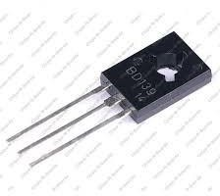

**Fig.3.3 Transistor**

Description:

The BD139 is an NPN power transistor designed for high current and high voltage applications. It is commonly used for switching and amplification purposes in electronic circuits. The transistor has three terminals: the emitter (E), the base (B), and the collector (C).

Working:

In an NPN transistor, a small current flowing into the base terminal allows a much larger current to flow from the collector to the emitter. When a positive voltage is applied to the base relative to the emitter, it forward-biases the base-emitter junction, allowing current to flow. This, in turn, allows current to flow from the collector to the emitter, acting as an electronic switch or amplifier.

Uses:

* Switching: Used to turn electronic devices on and off.
* Amplification: Increases the amplitude of electrical signals.
* Current Regulation: Controls the flow of current in circuits.

Applications:

* Audio Amplifiers: Used to amplify audio signals in various audio equipment.
* Power Supplies: Used in the regulation and switching of power in power supply circuits.
* Motor Control: Controls the speed and operation of motors in various applications.
* Relay Drivers: Used to control relays in electronic circuits.

### LED (Light Emitting Diode)

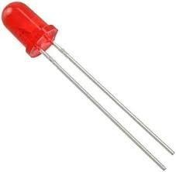

**Fig.3.4 LED**

Description:

An LED is a semiconductor device that emits light when an electric current flows through it. The light is produced through a process called electroluminescence, where electrons recombine with holes within the device, releasing energy in the form of photons (light).

Working:

LEDs are made from materials like gallium arsenide or gallium phosphide. When a voltage is applied across the LED in the forward direction, electrons move across the junction between the n-type and p-type materials. As electrons recombine with holes in the p-type material, they release energy as photons, creating light. The color of the light depends on the materials used and the energy gap of the semiconductor.

Uses:

* Indicators: Used as indicator lights in electronic devices.
* Displays: Used in digital displays, including seven-segment displays and LCDs.
* Lighting: Used in residential, commercial, and industrial lighting.

Applications:

* Consumer Electronics: Used in TVs, remote controls, and other consumer electronics as indicators.
* Traffic Lights: Used in traffic lights and other signaling devices due to their high efficiency and long lifespan.
* Automotive Lighting: Used in headlights, tail lights, and interior lighting in vehicles.
* General Lighting: Used in residential and commercial lighting applications for energy- efficient lighting solutions.

### Ceramic Capacitors

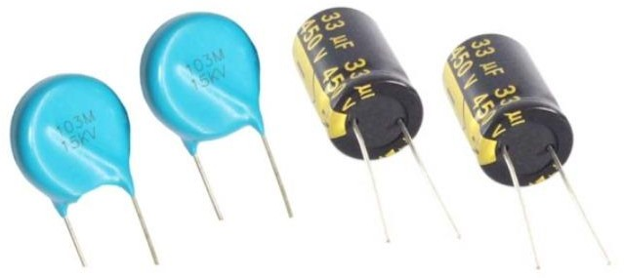

**Fig.3.5 capacitors**

Description:

Ceramic capacitors are fixed-value capacitors where the ceramic material acts as the dielectric. They come in various capacitance values and voltage ratings. The values given (0.47µF, 10nF, 4.7nF) indicate the different capacitances of the capacitors in the circuit.

Working:

Capacitors store electrical energy in an electric field created between two conductive plates separated by a dielectric material (ceramic in this case). When a voltage is applied across the plates, an electric field is established, and energy is stored. Ceramic capacitors have high-frequency characteristics, making them ideal for applications requiring fast response times.

Uses:

Filtering: Removes noise from power supply lines and signals.

* Coupling and Decoupling: Couples AC signals between stages of amplifiers and decouples power supply noise.
* Timing Circuits: Used in conjunction with resistors to create RC timing circuits.

Applications:

* Power Supplies: Used to filter out high-frequency noise from power supply lines.
* Signal Processing: Employed in audio and RF circuits to couple and decouple signals.
* Oscillators: Used in timing circuits for oscillators and clock generators in digital circuits.

### Resistor

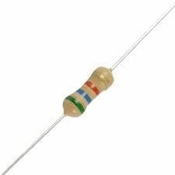

**Fig.3.6 Resistor**

Description:

A resistor is a passive electrical component that provides a specific amount of resistance to the flow of electric current. The value of the resistor (15kΩ) indicates its resistance in ohms.

Working:

Resistors work by opposing the flow of electric current through them, converting electrical energy into heat. This resistance is determined by the material, length, and cross-sectional area of the resistor. The relationship between voltage (V), current (I), and resistance (R) is described by Ohm's Law:

𝑉=IR

Uses:

* Current Limiting: Controls the amount of current flowing in a circuit.
* Voltage Division: Divides voltage into smaller, desired levels.
* Biasing: Provides proper operating voltages and currents in transistor circuits.

Applications:

* Voltage Dividers: Used to create reference voltages in analog and digital circuits.
* Biasing Transistors: Ensures transistors operate in the correct region by providing necessary base or gate currents.
* LED Current Limiting: Limits the current through LEDs to prevent damage.
* Pull-up and Pull-down: Used in digital circuits to set default logic levels.

### Battery



**Fig.3.7.Battery**

Description:

A battery is an electrochemical device that converts stored chemical energy into electrical energy. The 9V battery is commonly used in portable electronic devices.

Working:

Batteries consist of one or more cells, each containing an anode, cathode, and an electrolyte. During discharge, chemical reactions occur at the electrodes, creating a flow of electrons from the negative terminal (anode) to the positive terminal (cathode) through an external circuit, providing electrical energy.

Uses:

* Power Supply: Provides portable power for electronic devices.
* Energy Storage: Stores energy for later use.

Applications:

* + Portable Electronics: Powers devices like remote controls, smoke detectors, and multimeters.
  + Backup Power: Used in emergency lighting and backup power systems.
  + Prototyping: Commonly used in electronic projects and prototypes for testing circuits.

### 8. 2-Pin Connector:

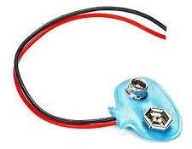

**Fig.3.8.Connector**

Description:

A 2-pin connector is a type of electrical connector with two pins used to connect wires to a circuit. These connectors provide a secure and detachable connection.

Working:

1. pin connectors consist of two conductive pins housed in an insulating material. When the connector is mated with its counterpart, the pins make contact, allowing electrical current to flow through the connection.

Uses:

* + Connecting Components: Connects different parts of a circuit.
  + Detachable Connections: Allows for easy assembly and disassembly of circuits.

Applications:

* + Power Connections: Used to connect power supplies to electronic devices.
  + Sensor Connections: Connects sensors to control circuits in automotive and industrial applications.
  + Prototyping: Facilitates easy connection and disconnection of components in prototype circuits.

### Heat Sink

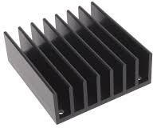

**Fig.3.9.Heat Sink**

Description:

A heat sink is a passive heat exchanger that dissipates heat generated by an electronic or mechanical device to the surrounding air or fluid medium.

Working:

Heat sinks work by increasing the surface area available for heat dissipation. They are typically made of materials with high thermal conductivity, such as aluminum or copper. The heat sink absorbs heat from the device and transfers it to the air or liquid through convection, conduction, or radiation.

Uses:

* Cooling: Removes excess heat from electronic components.
* Temperature Regulation: Maintains optimal operating temperatures. Applications:
* Computer Components: Used in CPUs, GPUs, and power supplies to dissipate heat.
* Power Electronics: Cools power transistors, voltage regulators, and other high-power devices.
* LED Lighting: Extends the lifespan of LEDs by preventing overheating.
* Industrial Equipment: Used in various industrial machines and equipment to manage heat dissipation.

### Rectifier

Description:

A rectifier is an electrical device that converts alternating current (AC) to direct current (DC). It typically consists of diodes arranged in a specific configuration.

Working:

Rectifiers use diodes, which allow current to flow in only one direction. In a half-wave rectifier, a single diode blocks half of the AC cycle, allowing only the positive or negative half to pass through. In a full-wave rectifier, multiple diodes are used to convert both halves of the AC cycle into DC. The output is then smoothed using capacitors to produce a stable DC voltage.

Uses:

* + Power Conversion: Converts AC to DC for use in electronic devices.
  + DC Power Supply: Provides stable DC voltage from an AC source.

Applications:

* + Power Supplies: Used in power supplies for converting AC mains electricity to DC voltage required by electronic circuits.
  + Battery Charging: Converts AC to DC for charging batteries.
  + Radio Signal Demodulation: Used in demodulating AM radio signals
  + Welding: Provides DC power for welding equipment.

### 9. Diode (1N4148)

**Fig.3.10.Diode**

Description:

The 1N4148 is a standard small signal silicon diode known for its fast switching speed and low forward voltage drop. It is widely used in electronic circuits for various applications.

Working:

A diode allows current to flow in only one direction. When forward-biased (positive voltage applied to the anode), it conducts current with a small voltage drop (typically 0.7V for silicon diodes). When reverse-biased (positive voltage applied to the cathode), it blocks current flow, acting as an insulator. The 1N4148 diode can switch from conducting to non-conducting states very quickly, making it ideal for high-speed applications.

Uses:

* + Rectification: Converts AC to DC in power supply circuits.
  + Signal Demodulation: Extracts information from modulated signals.

Applications:

* + Switching Circuits: Used in fast switching applications due to its quick response time.
  + Voltage Clamping: Protects sensitive components from voltage spikes by clamping excess voltage.
  + Logic Circuits: Used in digital logic circuits for signal routing and level shifting.
  + Oscillators and Timers: Used in oscillator and timing circuits due to its predictable forward voltage drop.
  + Each component listed plays a vital role in the functionality of electronic circuits, contributing to the performance, efficiency, and reliability of various devices and systems.

### 3.4 CIRCUIT DESCRIPTION :

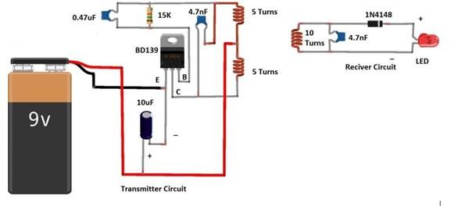

**Fig.3.11 circuit diagram**

The following is a detailed description of each component and their roles within the system.

## 3.4.1 Transmitter Circuit

### Power Source

* + **9V Battery**: Provides the necessary DC power supply for the transmitter circuit.
  + Oscillator Circuit
  + **BD139 Transistor**: Acts as an amplifier and oscillator in this circuit.
  + **E (Emitter)**: Connected to the negative terminal of the battery.
  + **B (Base)**: Connected through a 15k ohm resistor and a 0.47 µF capacitor to the positive terminal of the battery.
  + **C (Collector)**: Connected to the one end of the 5-turn coil.
  + **15k Resistor**: Limits the base current of the transistor to protect it from damage.
  + **0.47 µF Capacitor**: Works with the 15k resistor to form a timing network for the transistor’s oscillation frequency.
  + **10 µF Capacitor**: Smooths the DC supply to ensure stable operation of the transistor.
  + Transmitter Coil
  + **5-Turn Coil (x2)**: Two 5-turn coils are used in the transmitter side to create the magnetic field necessary for power transfer. They are connected in series with the collector of the transistor.

## 3.4.2 Receiver Circuit

### Receiver Coil

* + **10-Turn Coil**: Captures the magnetic field generated by the transmitter coil and induces a voltage.
  + **4.7 nF Capacitor**: Works with the receiver coil to form a resonant circuit tuned to the frequency of the transmitter.
  + Rectification and Smoothing
  + **1N4148 Diode**: A fast switching diode used to rectify the AC voltage induced in the receiver coil into DC voltage.
  + **4.7 nF Capacitor**: Further smooths the rectified DC voltage to reduce ripples.
  + Load
  + **LED**: Acts as an indicator to show the presence of received power. The LED lights up when sufficient voltage is received from the transmitter.

## 3.4.3 Circuit Operation

### Transmitter Operation:

**The 9V battery powers the transmitter circuit.**

* + The transistor BD139, along with the 15k resistor and 0.47 µF capacitor, forms an oscillator that generates an alternating current (AC) signal at a specific frequency.
  + This AC signal flows through the 5-turn transmitter coils, creating an alternating magnetic field around them.

### Magnetic Coupling:

* + The alternating magnetic field generated by the transmitter coils induces an AC voltage in the 10-turn receiver coil due to electromagnetic induction.

**Receiver Operation:**

* + The induced AC voltage in the receiver coil is rectified by the 1N4148 diode, converting it into a pulsating DC voltage.
  + The 4.7 nF capacitor smooths the rectified voltage to provide a more stable DC output.
  + The LED connected across the output terminals lights up, indicating the successful transfer of power wirelessly from the transmitter to the receiver.

3.4.4 Key Points

**Resonance**: The transmitter and receiver circuits are tuned to the same resonant frequency using the combination of inductors (coils) and capacitors. This tuning maximizes the efficiency of power transfer.

**Efficiency**: The efficiency of this WPT system depends on the alignment and distance between the transmitter and receiver coils. Optimal alignment ensures maximum power transfer.

Applications: Such a circuit can be scaled up and modified for various applications, including charging of electric vehicles, portable electronic devices, and other wireless power transfer applications.

This circuit serves as a basic demonstration of wireless power transfer technology using resonant inductive coupling. For practical and higher power applications, more sophisticated designs with higher quality components and safety features are required

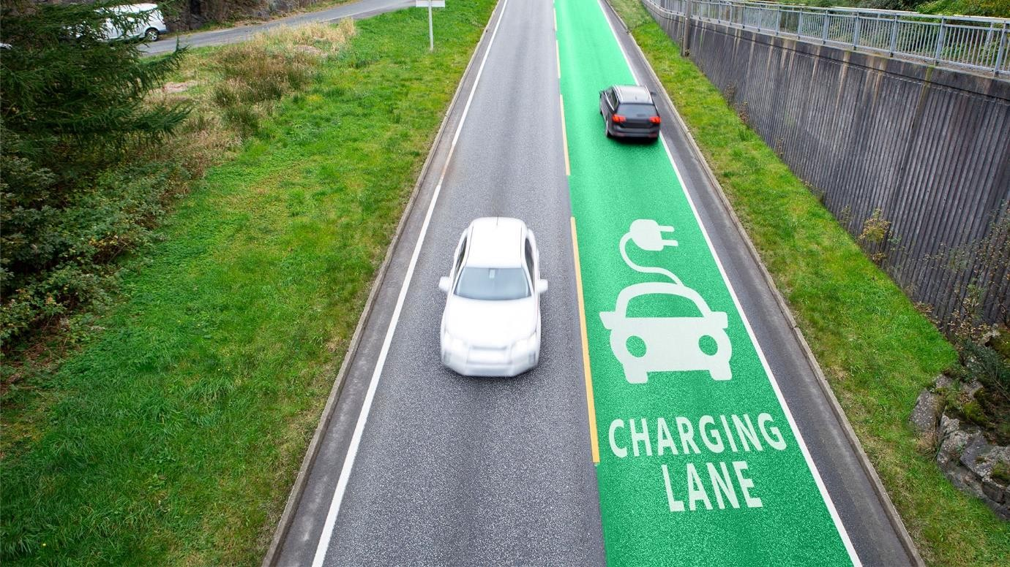

**Fig.3.12 Charging lane**

# CHAPTER 4

## 4.1 Result

**Case 1:**When the vehicle is on regular/normal road it is not charging.

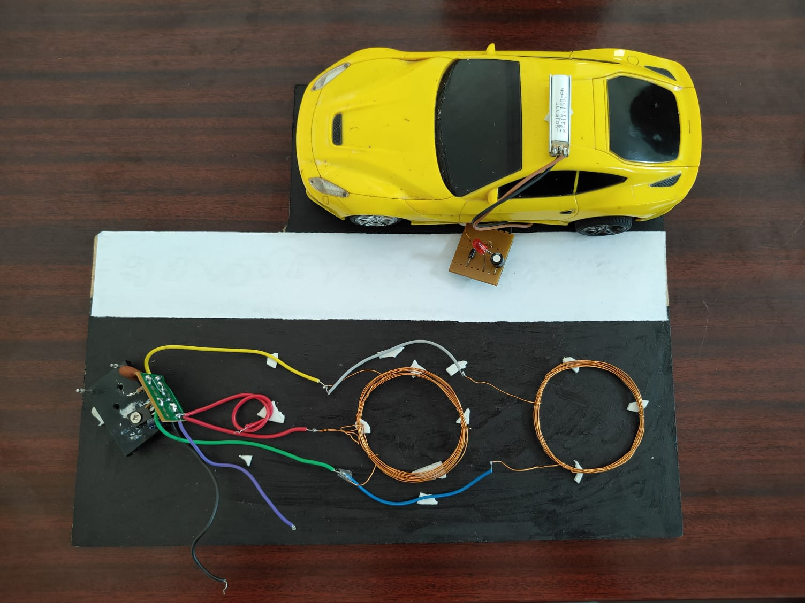

## Fig:4.1 vehicle discharging

**Case 2:** When the vehicle is on dynamic charging lane the vehicle gets charged.

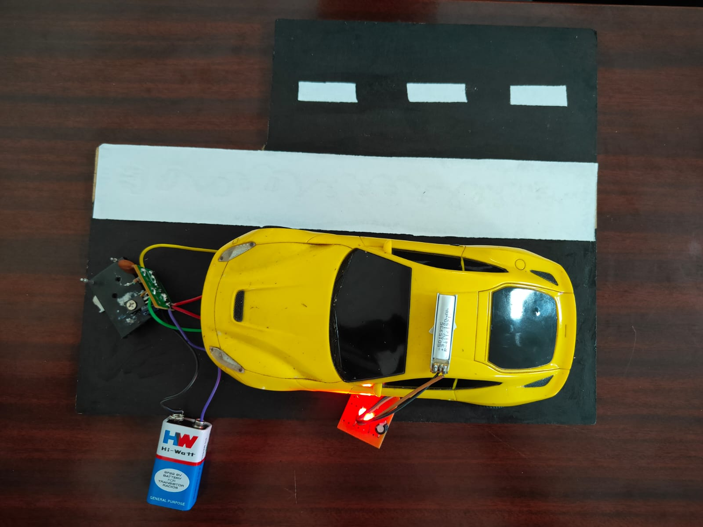

**Fig:4.2 Vehicle is charging**

# CHAPTER - 5

# 5.1. CONCLUSION

The results of this project demonstrate the feasibility and potential of using resonant magnetic coupling for wireless power transfer in electric vehicles. The prototype system achieved high power transfer efficiency under optimal conditions and showed good tolerance to misalignments and variations in distance. While several practical challenges remain, the findings indicate that WPT technology can significantly enhance the convenience and practicality of EV charging, supporting the broader adoption of electric vehicles..

* 1. **FUTURE SCOPE:**

Future work should focus on improving alignment mechanisms, enhancing thermal management, and exploring advanced materials to further optimize the system's performance and cost-effectiveness..

# CHAPTER - 6

**BIBLIOGRAPHY**

The sites which were used while doing this project:

* + - https://hal.science/hal-04420080/ [www.microchip.com](http://www.microchip.com/)
    - https://ieeexplore.ieee.org/abstract/document/10198186
    - https://pubs.aip.org/aip/acp/article-abstract/2901/1/070010/2930049/Designing- inductive-coils-for-wireless-power?redirectedFrom=fulltext
    - https:/[/www](http://www.mdpi.com/).[mdpi.com](http://www.mdpi.com/)

The references which were used while doing this project:

* Zhang, Yanyu, et al. "Ev-road-grid: Enabling optimal electric vehicle charging path considering wireless charging and dynamic energy consumption." 2021 IEEE 94th Vehicular Technology Conference (VTC2021-Fall). IEEE, 2021.
* Qiang, Xing, et al. "Route planning and charging navigation strategy for electric vehicles based on real-time traffic information and grid information." IOP Conference Series: Materials Science and Engineering. Vol. 752. No. 1. IOP Publishing, 2020.
* Lee, Ki-Beom, Mohamed A. Ahmed, Dong-Ki Kang, and Young-Chon Kim. "Deep reinforcement learning based optimal route and charging station selection." Energies 13, no. 23 (2020): 6255.